**Sapient XT Hiring test problem statement:**

**[Problem Statement]**

Develop a front-end application which would let the users help list and browse all Characters of Rick and Morty Show.

**[Minimum Requirement]**

— Use of Web API to fetch Characters details.

Response Parameters to be used:

[ ID, Name, Status, Species, Gender, Image, Created, Origin, Last Location, etc].

**Key Features:**

* Visually interactive responsive design listing all the characters.
  + Mobile should be of 2 column design while desktop and Tablet should have 4 columns.
* Make sure the standard Web development NFRs are taken care.
* A feature to Search (via name) should be implemented.
* Implement Sort feature (to filter through ‘id’ in ascending and descending order).
* Implement Filters to filter out data based on Species and Gender.
* Custom elegant design, fonts and icons to make web app more user-friendly.
* Use your imagination and add features which would make things easier for end users.
* You may add portfolio activity comprising awesome work you have done on web application(s).

**Build and local environment set-up requirements:**

* Some bundling package should be used to deliver the static assets for the web page, preferably Webpack.
* Standard Linting processes should be set as part of local dev environment which should run with build process.

**Guidelines:**

Submit Screenshot, Source code & Instructions.

**API to be used:** <https://rickandmortyapi.com/api/character/>

**— Ideal Frontend Stack:**

* Any of your favorite JS Framework: Javascript (ReactJS), HTML, CSS.
* Custom CSS – You can use any standard library. A CSS-in-JS approach is also something that you can explore for React etc.
* Optional: Typography, Subtle pattern, Custom Icons.

**— PS: Application can be built with use of client-side scripting but having server-side rendering would be a plus point.**

**— For icons and subtle texture:**

* http://glyphsearch.com/
* http://subtlepatterns.com/thumbnail-view/
* http://codebeautify.org/jsonviewer

<http://www.flaticon.com/categories>

**[Code Submission]**

Check in your code in to github and share the URL.

**DESIGNS BELOW:**

**Mobile Design:**

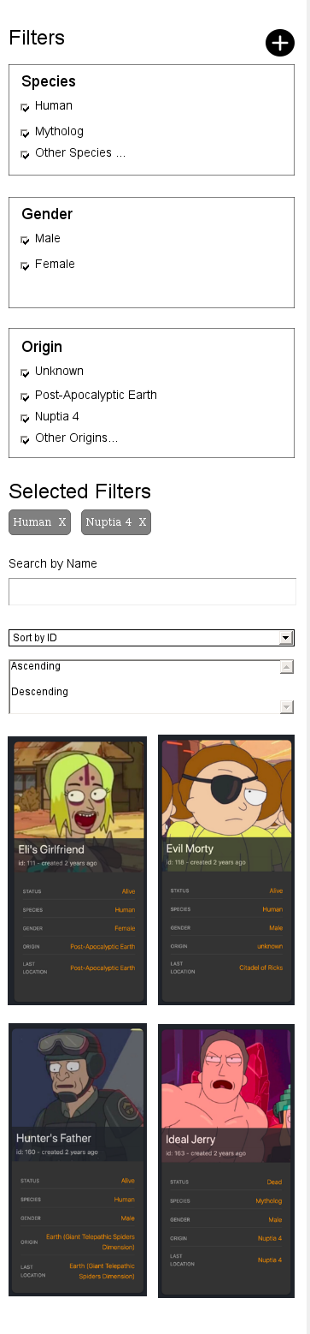

**Desktop Design:**

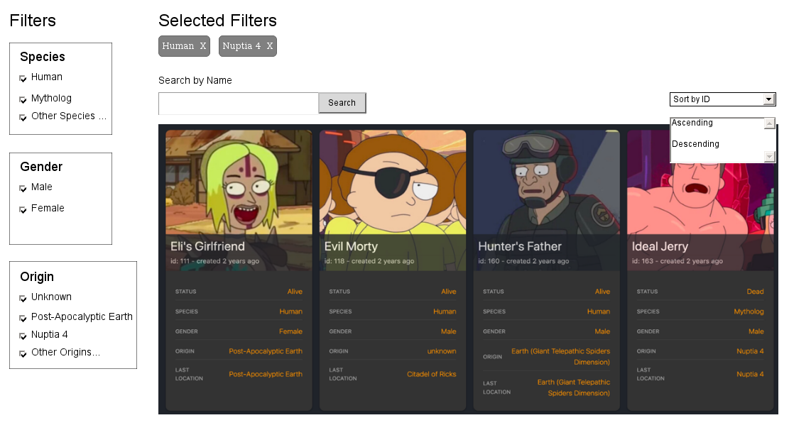

Basic Instructions:

<https://github.com/akhilesh2310/pscasestudy/blob/master/instructions.txt>

Screenshots URLs:

<https://github.com/akhilesh2310/pscasestudy/blob/master/1.png>

<https://github.com/akhilesh2310/pscasestudy/blob/master/2.png>

<https://github.com/akhilesh2310/pscasestudy/blob/master/3.png>

<https://github.com/akhilesh2310/pscasestudy/blob/master/4.png>

Source Code:

<https://github.com/akhilesh2310/pscasestudy/tree/master/src/app>

Features covered:

1. Listing of characters
2. Search by Name
3. Sorting by ID
4. Responsive UI
5. Build included as dist folder in github to run locally using httt-server node package

Filter by tags functionality is pending due to time constrains.